The NEW Roger Wilco by GameSpy ™.
Version MK1D2

Hosting a base station.

After installing RW and setting it up, this is what the main page looks like.

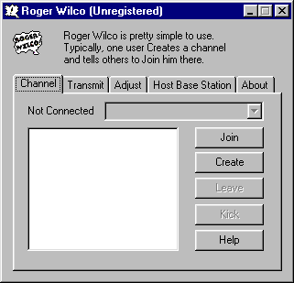

To host an RW Channel, you now have to host a base station or in other words create a channel. With version mk1d2, you can no longer just give someone your IP, but don’t despair. It’s pretty simple. Click on the Host Base Station tab to begin the process and name and password protect your channel.

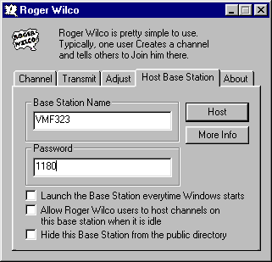

Click “Host” and a DOS screen will appear. This is the base station program running. You can minimize this screen, but don’t close it. You are still going to have to join the channel, even though you created it.

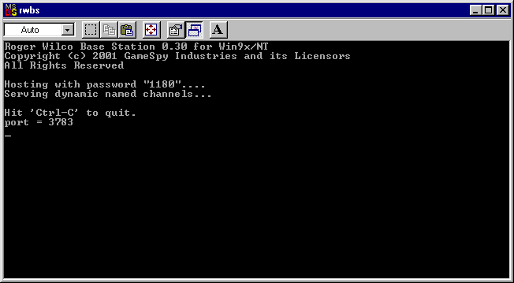

Another alternative.
You can create a channel by simply clicking Create on the Channel tab. This brings up another window similar to the Host Base Station tab. You’ll be asked to fill in the same type of info and then click Create to start the channel. The only difference I can see between them is that the Base Station runs as it’s own program, (in DOS). This allows someone to create a base station and leave it running on a PC or server that is up all the time. This makes it easy for others to rejoin by not having to create the channel and let everyone know it’s out there, since it’s always up and running.

Rumor on the RW forums is that GameSpy will be taking down the servers that were used by the previous version to host channels. Can’t blame them, it’s hard to maintain a server that isn’t generating income. Thus, they created this version to allow individual users to host channels and eliminate overhead.

Joining a base station channel.

Joining a channel has become a little more involved even if you created the base station, as it does not automatically add you to the channel. The base station, in a sense, runs as a separate program. To join any base station including the one you may have created, you have to go to the Channel tab and click “Join”.

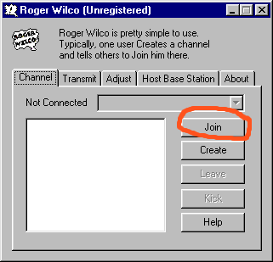

Another screen will pop up and will begin loading all the available channels. The trick is finding the channel you want to join. To make things easy, click on the channel header to alphabetize the channels.
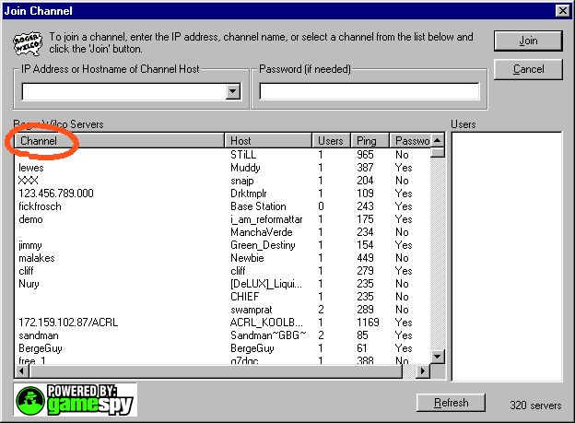

You’ll now have the servers alphabetized. Scroll down until you find the channel you want, in this case VMF323 (1). Select it by clicking on it and the IP and host name will appear in the IP address box (2). You will need to type in a password (3) if needed. You are now ready to join (4).

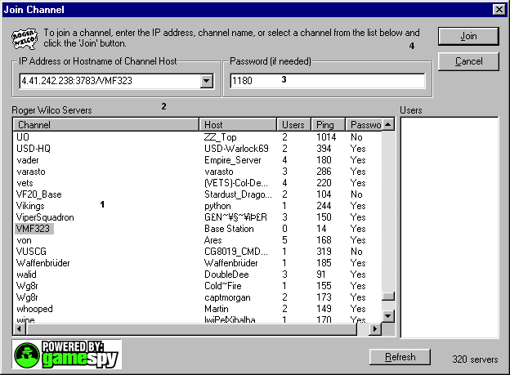

You should now get something like this and are ready to start talking.

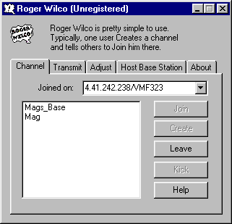

A few things to note here is that the IP address in the Joined on box is not the same as it appeared on the Join Channel window. For instance, in our case, if you told someone to join on 4.41.242.238/VMF323 and they entered that instead of joining through the Join Channel window, they would get the following error.

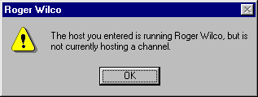

If you have problems or questions, feel free to send me a line or better yet go to RogerWilco.com and search the help files as they hold a lot of answers, just not a lot of helpful pictures. =)

Mag

Magnum_VMF323@yahoo.com

