Installing the CFS2 panel and gauges.

Once you have CFS2 gauges and panel zip file, go to the folder you downloaded them too. You should see something like this.

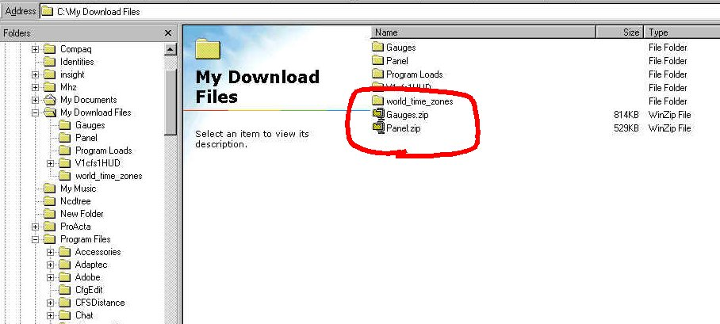

Once you have unzipped the files you’ll see something like this.

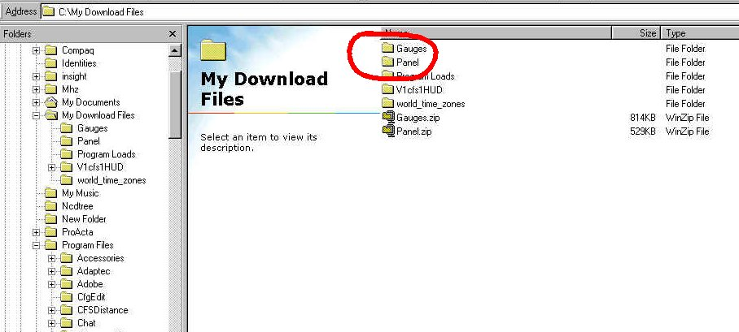

RIGHT click on the gauges folder and drag it to the folder Program Files/Microsoft Games/Combat Flight Simulator 2 and drop it.

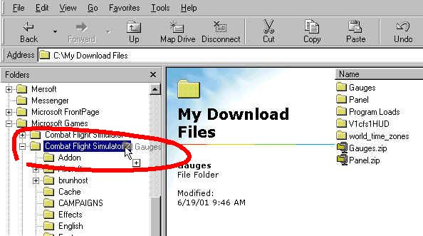
Select “Copy Here” You’ll get a conformation window like below, select “Yes to All”.

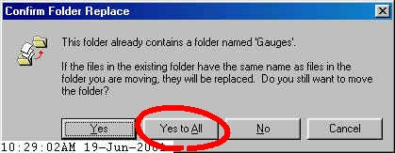

Next choose an aircraft folder you wish to use this panel in and make a copy of the original panel folder for safekeeping. Once you are satisfied you have a backup copy, RIGHT click on the panel folder you downloaded and unzipped from the utility page and copy it into the aircraft folder of choice, like this;

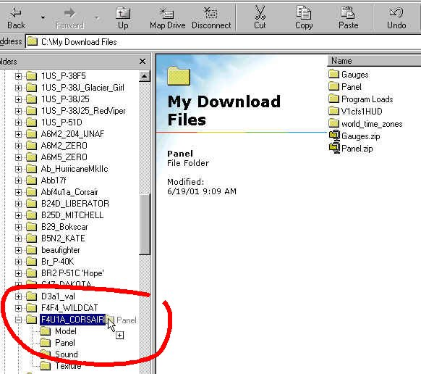

Select “Copy Here” and you’ll get a similar message as the gauge folder. Choose “Yes to All”.

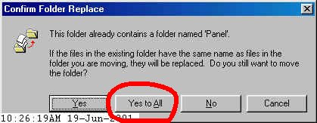
That’s it! You’re ready to try out the GPS and Fuel Dump. Fire up CFS2 and go to Free Flight. Choose the plane you put the new panel in and start flying. In panel view, you should see something like this.

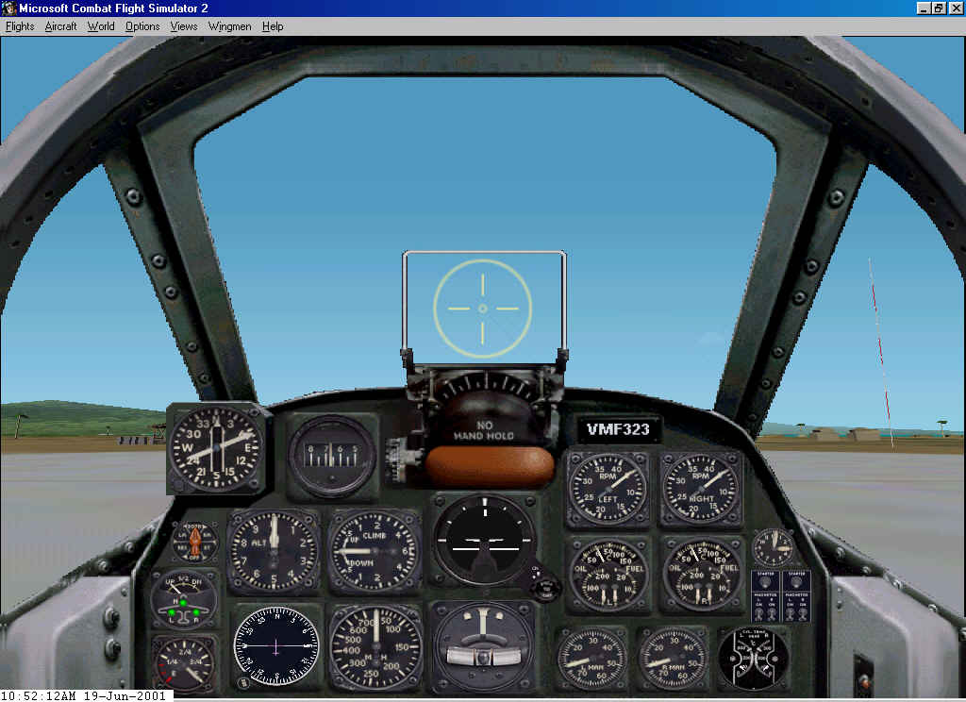

Now for the gauges, to bring up GPS, hold down the shift key and hit 5. In the lower right hand corner you should see this.

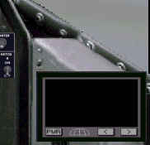
Hit the PWR button and scroll through the airfields and it gives you a mini compass with miles to the airfield like this.

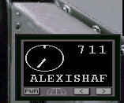

Now left click on the gauge and drag it up a few inches out of the way. Hold the shift key down and hit 6. Your lower right hand corner should look like this.

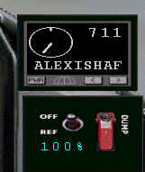

Walla! You have fuel dump. Select the percentage of fuel you want by clicking on the percentage indicator and click the red lever. Your fuel will magically drop to the amount specified. Running low on fuel? Click the Off/Ref toggle switch and you’ll refuel without having to stop at the fuel pump. (Note: this will not refuel your water injection.)

This panel also contains the ADF gauge, which can be accessed by holding down the shift key and then 2. But for this to operate correctly, you’ll need to install the fueladf scenery.

Shift + 4 will bring up your throttle controls. Since the throttle is only good for up to a twin-engine plane, I do not recommend that you install this in a bomber.

